Pulsed Laser Deposition

Pulsed Laser deposition (PLD) uses an intense high power laser pulse for ablation of a target to generate plasma plume. The ablated material in plume form is collected as [thin film](https://www.sciencedirect.com/topics/materials-science/thin-films) on substrate. PLD has progressively became a well-suited technique for the growth of [thin films](https://www.sciencedirect.com/topics/materials-science/thin-films) of materials with a complex stoichiometry.

The principle of PLD is based on the laser-matter interaction that happens when a high-energy laser beam hits a target. Species contained in the solid (or liquid) target are ripped out and generate a plasma plume. Plume is the evaporated material which is energetic composed of electrons, atoms, molecules ions, clusters, and globules.

This plume is deposited on the substrate.

Ions present in the plasma will then be condensed on a substrate surface. ( see Fig)Repetition of laser shots leads to an accumulation of matter onto the substrate surface driving to the formation of a [thin film](https://www.sciencedirect.com/topics/materials-science/thin-films). This very simple principle bestows to PLD a very high flexibility over a large panel of deposited materials.

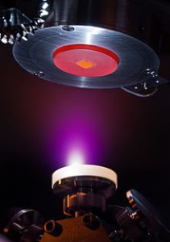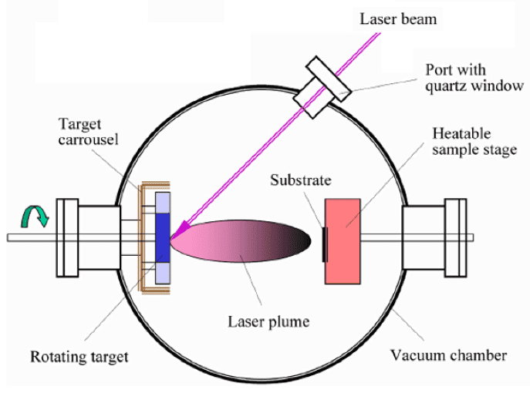

SUBSTRATE

PLUME

When laser beam interacts with source material and induces ablation, it can cause rapid heating and cooling of the source material with very high temperature. Hence, an instant evaporation is possible over small areas of the target. Power is delivered in the form of high-power pulses creating flash evaporation condition, which leads to an important advantage of congruent evaporation of compound materials.

When the high-power laser radiation falls on the surface of a solid, it will be absorbed only when the energy density is greater than the ablation threshold and converted into electronic excitation and then into thermal energy to cause evaporation, ablation, and excitation.

It is a [physical vapor deposition](https://www.sciencedirect.com/topics/materials-science/physical-vapor-deposition) technique in which a high-power pulsed laser is directed toward a target material with the aim of decomposing the target material to be vaporized, that is, to form a plasma plume. This plasma plume is to be deposited on a nearby substrate. The PLD chamber can be operated at an UHV or in the presence of some background gas(es). PLD is frequently used for the deposition of a variety of oxides and in that case oxygen is used as the background gas. This is to ensure the complete oxidation of the deposited material. The PLD system is much less complex compared to other physical deposition systems like the CVD or MBE. Nevertheless, the process of [laser ablation](https://www.sciencedirect.com/topics/materials-science/laser-ablation) is quite complex. As the laser strikes the target material, its energy is transferred as electronic excitation which is then converted into thermal, chemical, and mechanical energy which leads to ablation, plasma formation, and evaporation of the constituents of the target material. The evaporated material spreads then in the chamber as an energetic plume species composed of electrons, atoms, molecules ions, clusters, and globules, that reach the substrate, which is heated to a specific temperature determined by the growth properties of the material to be deposited. The substrate is rotated at a constant speed to ensure the uniform deposition. As mentioned above the whole of process of PLD is complex in nature, including the laser ablation and the plasma plume including the high energetic species.

In principle the PLD is dependent on five different parts that have to be optimized carefully for the growth of high-quality crystal materials. These are:

1.

Absorption of the laser by the target material

2.

Laser ablation of the target material and the formation of the plasma

3.

Plasma dynamics

4.

Deposition of the ablation material on the substrate

5.

Nucleation and growth of the required film

All the above stages are critical for the formation of high-quality crystal.

#### ****ADVANTAGES****

1 It is easy to obtain multi- component film that is of the desired stoichiometric ratio by PLD.

2 It has high deposition rate, short test period and low substrate temperature requirements. Films prepared by PLD are uniform.

3 The process is simple and flexible with great development potential and great compatibility.

4 Process parameters can be arbitrarily adjusted, and there is no limit to the type of PLD targets. Multi-target components are flexible, and it is easy to prepare multilayer films and heterojunctions.

5 It is easy to clean and can prepare a variety of thin film materials.

6 PLD uses UV pulsed laser of high photon capability and high energy density as the energy source for plasma generation, so it is non-polluting and easy to control.

**Disadvantages**

1 For quite a number of materials, there are molten small particles or target fragments in the deposited film, which are sputtered during the laser-induced explosion. The presence of these particles greatly reduces the quality of the film.

2 The feasibility of laser method for large area deposition has not been proved yet.

3 Average deposition rate of PLD is slow.

4 In view of the cost and deposition scale of laser film preparation equipment, it seems that PLD is only suitable for the development of high-tech fields such as microelectronics, sensor technology, optical technology and new material films.